**Experiment No. 09**

**Aim: Program to demonstrate CRUD (create, read, update and delete) operations on database (SQLite/ MySQL) using python.**

**Code:**

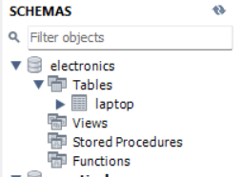**Creating database and table:**

import mysql.connector

mydb = mysql.connector.connect(

 host="localhost",

 user="root",

 password="root",

 database="electronics"

)

mycursor = mydb.cursor()

mycursor.execute("""CREATE TABLE Laptop (

Id int(11) NOT NULL,

Name varchar(250) NOT NULL,

Price float NOT NULL,

Purchase_date Date NOT NULL,

PRIMARY KEY (Id))""")

**Inserting Records:**

mycursor = mydb.cursor()

sql = """INSERT INTO Laptop (Id, Name, Price, Purchase_date)

 VALUES

 (%s,%s,%s,%s) """

val = [(2, 'Area 51M', 6999, '2019-04-14'),(3, 'MacBook Pro', 2499,

'2019-06-20'),

 (4, 'Asus', 8000, '2020-04-14'),(5, 'HP', 15000, '2019-05-10')]

mycursor.executemany(sql, val)

mydb.commit()

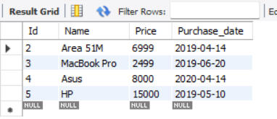

**Deleting a record:**

mycursor.execute("DELETE FROM Laptop WHERE NAME = 'Asus' ")

mydb.commit()

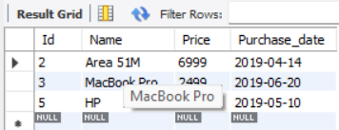

**Updating a record:**

mycursor.execute("UPDATE Laptop SET Price = 25000 WHERE NAME = 'HP' ")

mydb.commit()

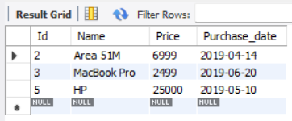**Selecting records starting with A:**

mycursor.execute("SELECT * FROM Laptop WHERE Name LIKE 'A%' ")

myresult = mycursor.fetchall()

for x in myresult:

 print(x)

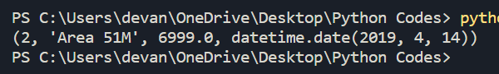

**Alter table:**

mycursor.execute("ALTER TABLE Laptop ADD Year int(10) ")

mydb.commit()

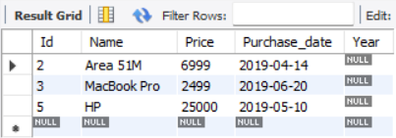**Drop table and database:**

mycursor.execute("DROP TABLE Laptop")

print('Table Dropped')

mycursor.execute("DROP DATABASE electronics")

print('Database dropped')

mydb.commit()

